select substr('developer',-1,5) from dual;

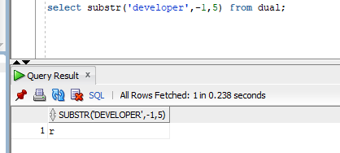

select substr('developer',4) as string from dual

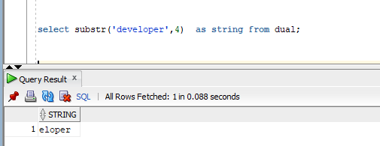

select substr('developer',-9) as substring from dual;

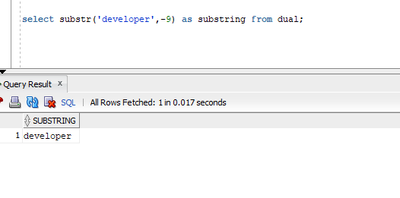

select substr('developer',1,-4) from dual

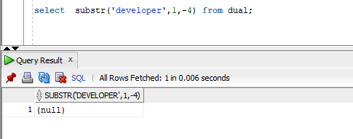

select substr('developer',-3,3) from dual

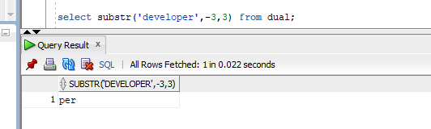

SELECT

INSTR( 'This is a playlist', 'is' ) substring_location

FROM dual

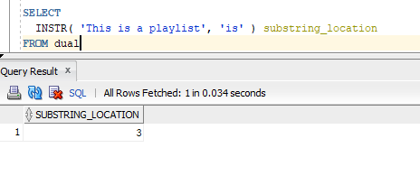

SELECT

INSTR( 'This is a playlist', 'is', 1, 2 ) second_occurrence,

INSTR( 'This is a playlist', 'is', 1, 3 ) third_occurrence

FROM dual;

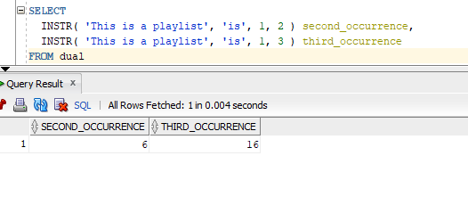

SELECT

INSTR( 'This is a playlist', 'are' ) substring_location

FROM dual;

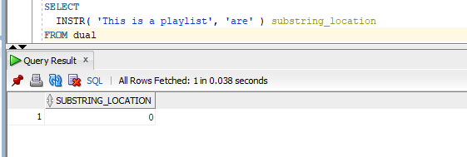

SELECT

INSTR( 'This is a playlist', 'is',-1 ) substring_location

FROM dual;

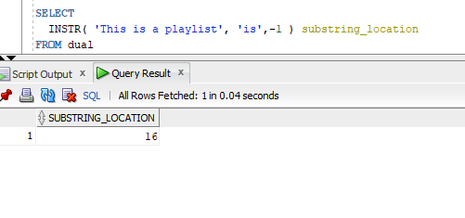

SELECT

INSTR( 'This is a playlist', 'l',1,2 ) substring_location

FROM dual;

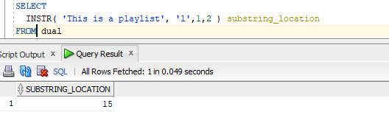

SELECT TRUNC(15.79,1) "Truncate" FROM DUAL;

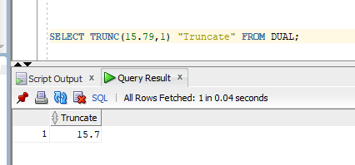

SELECT TRUNC(15.79,-1) "Truncate" FROM DUAL

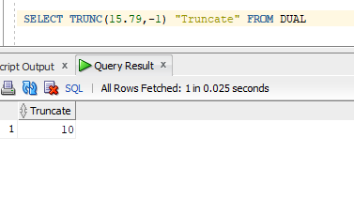

select trunc(10,-2) from dual;

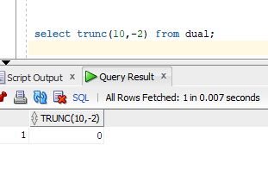

select rpad(9010219307,15,'*') from dual

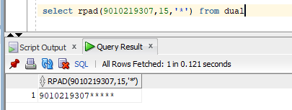

select lpad(9010219307,15,'*') from dual

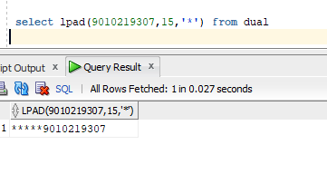

SELECT TRIM( 'k' FROM 'karthik') FROM DUAL;

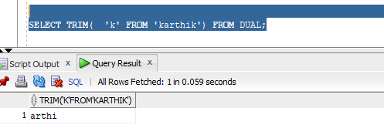

SELECT TRIM(TRAILING '0' FROM '123000') FROM DUAL;

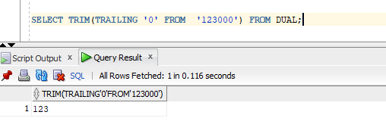

SELECT TRIM(LEADING '0' FROM '000123') FROM DUAL;

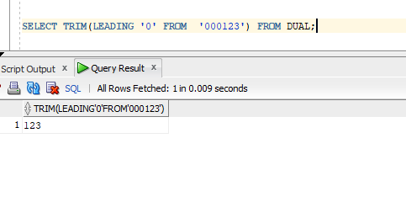

select replace('JACK AND JUE','J','BL') FROM DUAL

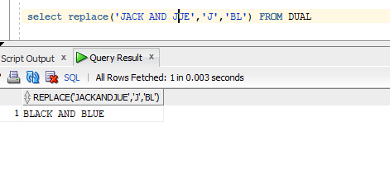

select upper('tharak') from dual

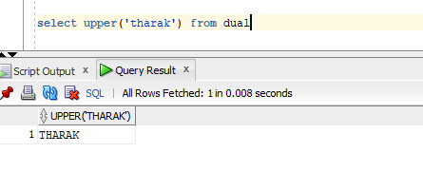

Select lower(‘THARAK’) FROM DUAL;

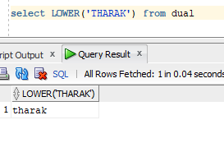

select INITCAP('tharak') from dual

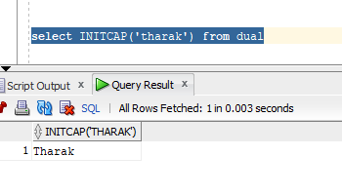

select sal,comm,nvl(comm,0) "comm is null print 0" from emp

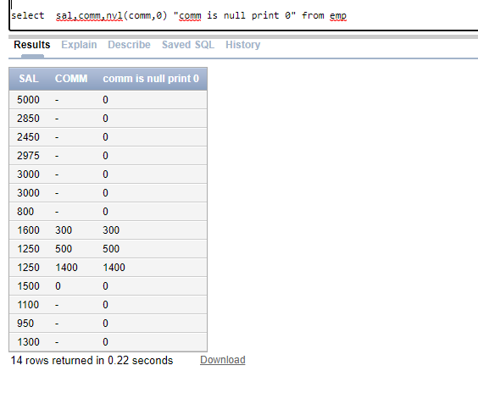

select sal,comm,nvl2(comm,sal+comm,sal) "comm is null print 0" from emp

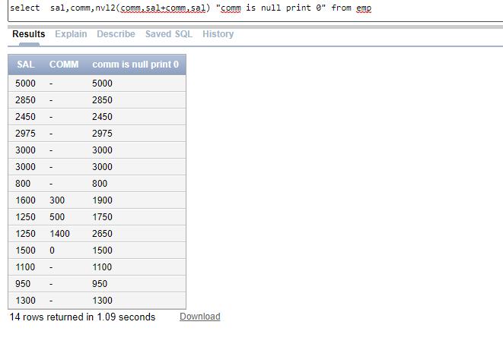

select sum(sal) from emp

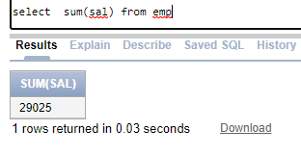

select round(avg(sal) ) from emp;

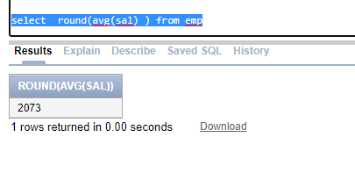

SELECT

SUBSTR('shiva sai shanka', 1, INSTR('shiva sai shanka', ' ')-1) AS col1,

SUBSTR( 'shiva sai shanka', INSTR('shiva sai shanka',' ')+1, INSTR('shiva sai shanka',' ',1,2)-INSTR('shiva sai shanka',' ')-1 ) as col2,

SUBSTR('shiva sai shanka',INSTR('shiva sai shanka', ' ',1,2)) AS col3

FROM dual;

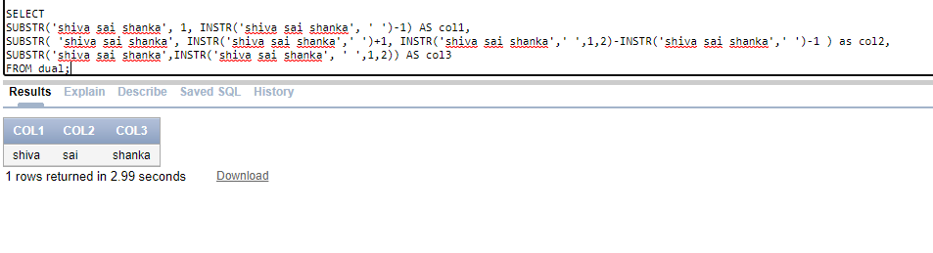

select localtimestamp from dual

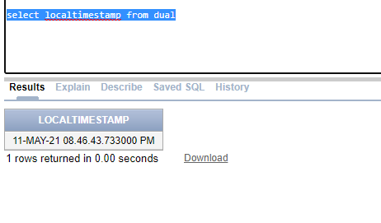

select sysdate from dual

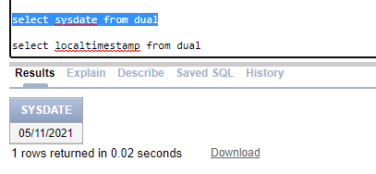

select add_months(sysdate,3) from dual

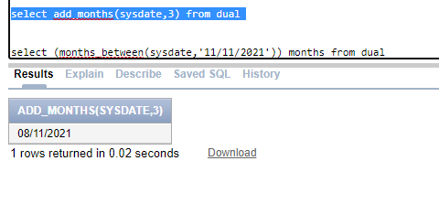

select (months_between(sysdate,'11/11/2021')) months from dual

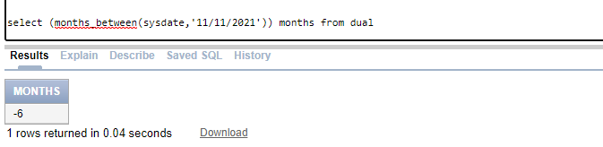

select next_day(sysdate,'saturday') from dual

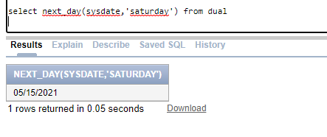

select current_date from dual

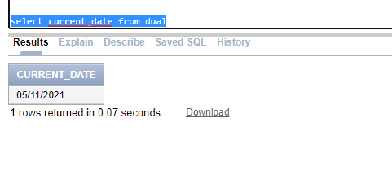

select distinct e.deptno,count(*) "dept count"

from emp e inner join dept d

on e.deptno=d.deptno

where e.sal>500

group by e.deptno

having count(*) >=3

order by e.deptno

